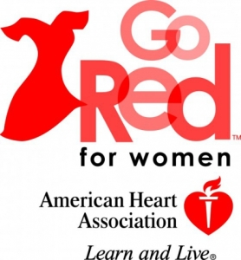
Heart Disease and Stroke in Black Women
Know the Facts:

- Heart Disease (Cardiovascular Disease) is the number 1 killer in United States
- Heart Disease kill more than 50,000 Black women annually. Stroke is a leading cause of death among Black women.
- Among Black women ages 20 and older, nearly 59% have cardiovascular disease (heart disease).
- Only 39% of Black women are aware that chest pain can be a sign of a heart attack; only 33% recognize that pain spreading to the shoulder, neck, or arms is another potential heart attack sign.
- Among Black women ages 20 years and older, nearly 58% have high blood pressure and only around 20% of those women have their blood pressure under control.
Signs and Symptoms of a Heart Attack:
- Uncomfortable pressure, squeezing, fullness or pain in the center of your chest. minutes, or goes away and comes back.
- Pain or discomfort in one or both arms, the back, neck, jaw, or stomach.
- Shortness of breath with or without chest discomfort.
- Other signs such as breaking out in a cold sweat, nausea, or lightheadedness.

Signs and Symptom of a Stroke:
F.A.S.T. is a simple way to remember the warning signs of a stroke. Note the time when any of the symptoms first appear. Any signs and symptoms of a stroke is an Immediate Medical Emergency. The sooner treatment is started, the better the outcomes. The sooner treatment is given after the first symptom begins, the more likely it is that a person will recover with little or reduced disability, and it might even save your life or the life of a loved one.
F. Face Drooping
A. Arm Weakness
S. Speech Difficulty
T. Time to Call 911
Symptoms may also include the following:
  - Sudden numbness or weakness of the face, arm, or leg, especially on one side of the body
  - Sudden confusion, trouble speaking or understanding
  - Sudden trouble seeing in one or both eyes
  - Sudden trouble walking, dizziness, loss of balance or coordination
  - Sudden, severe headache with no known cause

***Remember – Symptoms of a Heart Attack or Stroke is an Immediate Medical Emergency! Call 911!
For More information about Heart Disease and Stroke, see the fact sheets available or visit the American Heart Association’s website (see the link below).

