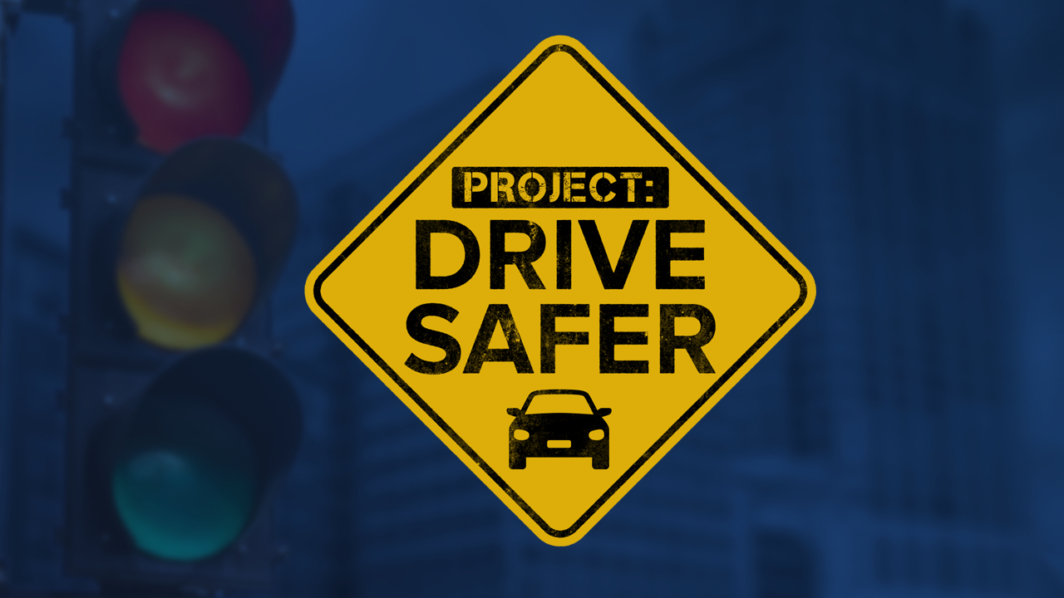

Project: Drive Safer Listening Session

May 17 @ 12:00 pm - 1:30 pm
It’s been more than six months since TMJ4 launched the Project: Drive Safer initiative. They have reported daily on this important topic – including when Governor Evers signed a reckless driving bill into law – but we still have a long way to go to make a difference on Milwaukee streets. Therefore, the TMJ4 team would like to get our feedback on how it’s going so far and what we need to focus on in the next 6 months.
Click here to sign up for the Zoom meeting and get the link.

