Looking to get your driver’s license?
Enroll in free Driver’s Education classes today.
Each session is three weeks long (15 classes) and takes place each month of 2023. Each session is limited to 20 participants. Every participant is expected to be on time and attend every session in its entirety. Boys & Girls Clubs membership required. Monday – Friday 5 – 7 p.m. Note: July session hours vary and take place from 10 a.m. – 2 p.m. and 1 p.m. – 3 p.m. July participants can choose the morning or afternoon session.
The Ready Center powered by the Milwaukee Admirals
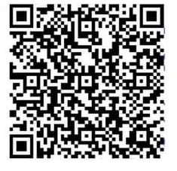
1916 N. Vel R. Phillips Ave., Milwaukee, WI 53212

Ages 15 – 17
To register visit bgcgm.club/trcdriversed or scan the QR code.
Filling out the form does not guarantee a spot in the class. Students must respond to the confirmation email.
For additional information, please email us at teenoutreachrecruitmentmanagers@bgcmilwaukee.org or call (414) 419-9073.
Career Development

