“CONSCIOUS AND INTENTIONAL MINISTRY:

DOING WHO I AM”

Also I heard the voice of the Lord saying: “Whom shall I send, And who

will go for Us?” Then I said, “Here am I! Send me.”
Isaiah 6:
8

Preaching, Teaching and Reaching for

Transformation and Liberation

THE PASTOR’S PEN

AUGUST 03
,, 2022

HOW DO I RESPOND TO THE WORD OF GOD?
Matthew 13:1-9 and 18-23

SEED SOWN BY THE WAYSIDE = A HARD HEART
- The Word makes it to my heart, but not in my heart
- Problem: I hear the Word and do not understand it, the evil one comes and snatches away what was sown in his heart
1. The Word makes it to my heart, but not in my heart 2. Why? My heart is not cultivated; not expecting to receive
3. What makes my heart become hard?
- Response: I must remove all internal and external barriers, and let the Word of God go inside of me

SEED SOWN ON STONY GROUND = A SHALLOW HEART
- The Word makes it in my heart, but not very deeply
- Problem: Someone hears the Word and receives it with joy. Yet, there is no root
  - The Word makes in the heart, but not very deeply
  - I endure for a while
  - But, when tribulation and persecution come (because of the Word), I immediately fall away
    - I’m trying to live the Word, and life is getting worse
    - I’m not living the Word, and others challenge with the Word
- Response: I must Go deeper with the Word of God through Bible Study and wrestling with the Word of God

SEED SOWN AMONG THORNS = A DISTRACTED HEART
- The Word makes it deeply in my heart, but it has competition
- Problem: I hear the Word and the cares of this world and the deceitfulness of riches choke the word and I become unfruitful
  - The Word makes it in my heart deeply, but it has competition
  - The Word is choked out by the cares of this world
    - I Peter 5:7, ⁷ casting all your care upon Him, for He cares for you.
    - Philippians 4:6, ⁶ Be anxious for nothing, but in everything by prayer and supplication, with thanksgiving, let your requests be made known to God
  - The Word is choked out by the deceitfulness of riches
    - I am deceived to focus on what I have versus who I have
    - I Timothy 6:17, ¹⁷ Command those who are rich in this present age not to be haughty, nor to trust in uncertain riches but in the living God, who gives us richly all things to enjoy. 4. I become unfruitful (I have leaves, but no fruit)
- Response: I must identify and remove the thorns/weeds from my life so the Word of God can grow and flourish in me

SEED SOWN ON GOOD GROUND = A GOOD HEART
- The Word makes it deeply in my heart, and it grows and produces fruit
- Hear the Word of God
- Understand the Word of God
- Grow
- Produce

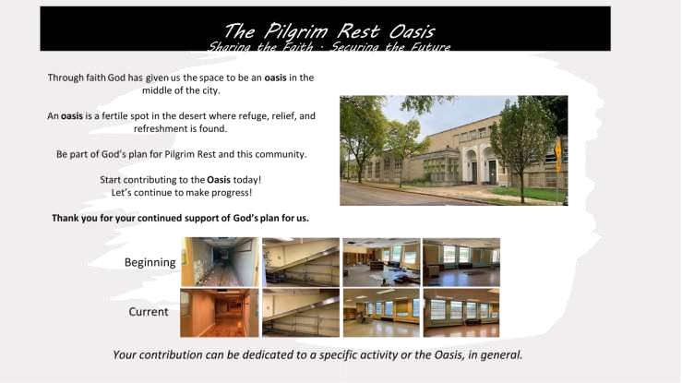

 |  | Educational Enrichment | Technology Literacy |  | Athletics & Recreation | Performing Arts | Facility Innovation
$500 | • | 15 Subject books for elementary (math, literature, history, etc.) | • 1 iPad | • | 10 basketballs | • 10 art sets for aspiring artists | • External security lighting to keep the street well-lit and safe
$1,000 | • | 100 Summer  Bridge books to help students retain learning during breaks | • 100 “learn how to code” kits for elementary students | • | 10 tennis rackets | • 4 beginner saxophones or 8 beginner violins | • Camera security system to keep everyone safe
$2,500 | • | 9 students can be challenged to excel using interactive problem-solving programs | • 1 computer for graphic design and website creation | • | 12 sets of golf clubs for children | • 10 Play Scripts with performance/ licensing fee and cast instructions | • Wireless PA system to easily communicate at the school
$5,000 | • | 1 smartboard to help teachers engage students in learning | • 1 STEM lab cart of materials for a classroom with multiple activities | • | 3-day Speed and Agility workshop for 15 young aspiring track stars | • 100 pairs of tap shoes for aspiring dancers | • Battery operated floor scrubber to keep the building looking its best
$10,000 | • | 1 trip for 15 students to visit 1  HBCU | • 100 Robotic kits to reinforce studies in  STEAM subjects | • | Open gym for 20 young people 1 X a week throughout the winter in a safe place | • 200 tickets to see  Alvin Ailey Dance  Company | • LED light fixtures throughout the school to promote learning and natural light

FOR THE YOUTH & Adults

For the month of August, I will commit to read my Bible every day

“We must remember that one person can make a significant difference, and that a small group of determined people can change the course of history” Sonia Johnson

