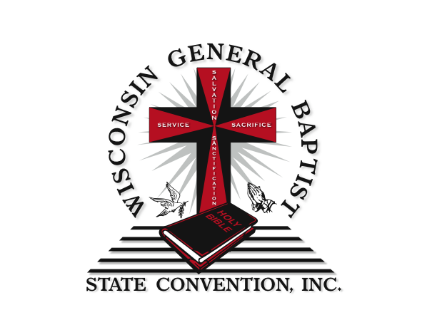

CONGRESS OF
CHRISTIAN EDUCATION
August 8 – 11, 2022

Held At
Christ The King Baptist Church
7750 N 60th Street Milwaukee, WI 53223

Congress Class Times:
6:00 p.m. – 9:00 p.m.

Theme:
Reaching Our Potential And New Possibilities
By The Power Of God

“Behold, I will do a new thing; now it shall spring forth; shall ye not know it?
I will even make away in the wilderness, and rivers in the desert.”
- Isaiah 43:19

I count not myself to have apprehended: but this one thing I do, forgetting those things which are behind, and reaching forth unto those things which are before, I press toward the mark for the prize of the high calling of God in Christ Jesus.
-Philippians 3:13-14

Sub-Theme:
Believing and Proclaiming God’s Promises!

Reverend Keith C. Evans, Convention President
Reverend James M. Ivy, Congress President
Sis. Jenell Williamson, State Congress Director
Sis. Emma Thomas-Brooks, Congress Dean

A Word to Our Delegates

Annual Session Theme:
Reaching Our Potential And New Possibilities
By The Power Of God

The last two years were one of the most uncertain, difficult, shuddering times in modern world history. Numerous issues resonated among us, gnawed at each of us and nearly knocked the winds out of our sails. Yet, it is important for us to be optimistic as God continues to live and freely moves among us and invites us to go beyond our worry and stress.

The prophet Isaiah bears witness of God’s bold plan: “Behold, I am doing a new thing; now it springs forth, do you not perceive….” (Isaiah 43:19, English Standard Version). In the New Testament, the apostle Paul gives prescription as to over come the pains and difficulties faced over the last two years when he writes: I do not consider that I have made it my own. But one thing I do: forgetting what lies behind and straining forward to what lies ahead, I press on toward the goal for the prize of the upward call of God in Christ Jesus” (Philippians 3:13-14, English Standard Version).

This year’s Annual Session theme is a call to believe that God is still in control and still has the power to redeem, revitalize and renew! And believing in God’s power, we can faithfully reach our full potential and, by God’s grace and power, attain the upward call of Christ. In 2022 you are being challenged to give God space to work new things in your life, to increase your faith and biblical knowledge and enjoy the blessings of Christian Education! Explore and live this hopeful promise of the “new thing” God is doing. Can you see it!? Look Forward!!!

Annual Session Sub-Theme:
Believing & Proclaiming God’s Promises!

Did you know as a Child of God, one of the greatest blessings you have is the right to claim the promises of God – promises that never fail! This Annual Congress Session we will steward the promises of God in the Church & Society and today’s culture. If you want to explore how to understand the culture of Generation Z and minister to them effectively; register for “Meet Generation Z: Understanding and Reaching the New Post-Christian World.”

Since a good faith community also is a welcoming community despite one’s mental health condition; a course entitled Mental Health and Church Security will be offered for delegates to receive instruction on implementing security measures and ministry that identify and address individuals with signs and symptoms of mental health and behavioral disorder. Delegates will also be encouraged to support their own mental health and explore a list of God’s promises in the Bible they can claim to take care of their own mental health. A Seminar from Daniel and the other from Isaiah, will remind us we can trust in God’s promises. Don’t miss your “new thing” God has for you! Come and explore this daring invitation to study God’s promises and prepare to receive all that God has for you when you Believe and Proclaim God’s Promises!

2022 Annual Session
Congress Course & Seminar Offerings

- Course # 1015 – Survey of Deuteronomy
Description: Guide the students in the repeating of the Law after the former generation of Israelites had died in the wilderness. ( Rev. John McBride)

- Course # 2007 – Christian Stewardship
Description: Cover the basic tenets of Christian stewardship – time, talent, and tithe. Students will begin to understand how to effectively manage their resources through a better understanding of the spiritual principles, practices, and contributions of Christian stewardship. (Rev. Archie Ivy)

- Course # 2061 – Millennials in Ministry - Meet Millennials and Generation Z
Description: Born approximately between 1993 and 2012, Generation Z now makes up more than 20% of the United States population. This course explains who this generation is, how it came to be, and the impact it is likely to have on the nation and the faith. This course invites class participants to embrace the ancient countercultural model of the early church, arguing that this is the model Christian leaders must adopt and adapt if we are to reach members of Generation Z with the Gospel. (Ms. Demetria Mallett)

- Course # 8033 – Church and Society
Description: Comparatively view the place of the Christian in the context of society. Focus on biblical references that define the role of the church in terms of living in the world and interacting with those outside the church. Separation of church and state will be discussed. (Rev. Reginald Ivy)

- Course # 8040 – The Biblical and Cultural Concepts of Marriage and Family
Description: Examine various definitions of marriage. Research marriage from various points of view, such as historical, legal, biblical, and cultural.
(Rev. Edward E. Thomas)

Seminar #1 – The Book of Daniel

The Book of Daniel contains Hope. Delegates will examine the many promises in the Book of Daniel and how God continues to advance His story until that story is complete.
(Rev. O. J. Newborn)

Seminar #2 – Book of Isaiah

The entire Book of Isaiah shows us we can trust God’s Promises. It is the Book of Isaiah that is grand narrative of the Bible! This course will focus on the comfort and hope for God’s people as Isaiah points to the promised Messiah who will deliver God’s people from their enemies and their sin. (Rev. Ray Murphy)

Seminar # 3 – Mental Health and Church Security

Description: Instruction on implementing security measures and ministry that identify and address individuals with signs and symptoms of mental health and behavioral disorder. Learning how to give to support their one’s own mental health and explore a list of God’s promises in the Bible to claim in order to take care of one’s own mental health. (Ms. Michelle Hampton)

Pastor’s and Minister’s Division Institute

The Pastor’s and Minister’s Division is open to pastors and ministers. There will be one plenary session which meets each day at 11:00 a.m.-1:00 p.m. (M,T,W)

Seminars offered in the Pastor’s and Ministers Division will include:

- The Work of Pastor In Ministry & Family Life
- Structuring and Strengthening Corporate Worship Post-Pandemic
- Biblical Preaching In The Present Age

Seminar for Associate Ministers/Non Pastoring Preachers
- Ministerial Ethics
- Sermon Preparation
- Discerning the Call

(Please direct your concerns to Dean Emma Thomas-Brooks: 414-699-5373 or email at emjantyangels@aol.com)

