“CONSCIOUS AND INTENTIONAL MINISTRY:
DOING WHO I AM”
Also I heard the voice of the Lord saying: “Whom shall I send, And who
will go for Us?” Then I said, “Here am I! Send me.” Isaiah 6:8
THE PASTOR’S PEN June 19, 2022
Preaching, Teaching and Reaching for
Transformation and Liberation

My Opinion Editor:
WHY ARE OUR CHILDREN “BORED”?
By Jake P. Beason
Author of WHY WE LOSE
When I was growing up in the South before World War II, I had no time to be "bored". I had so
many things to do around the house: taking out the ashes, emptying the pan under the icebox,
running to the store, scrubbing the floors on my knees. Every day I looked forward to finally
finishing my chores so that I could go out to play with my friends or go walking in the woods.
But today the most common complaint among children is “I'm so bored. There's nothing to do
around here.” So parents worry about how they are going to make life more entertaining for
their children to keep them out of trouble. They take them shopping to buy fancy clothes and
give them money to go to the show and concerts, never asking themselves what kind of adults
and what kind of society we are creating by raising our children to believe that life should
always be fun and full of goodies.
The family used to be a place where children were needed to do things. Children had a sense of
their value (or what we now call “Self-Esteem”), because they knew they were making a
contribution. But today there is little in the way of useful activities that the average family has
to offer children. In single-parent or two-parent households, adults go off to work and send the
kids off to school or to a baby-sitter. Then when the parents come home, they feel they ought to
offer the kids something to amuse them.
The family used to be a place where children learned that to be a full human being you need to
do your share of the work that is necessary to maintain the household. By working around the
house children learned early in life what it means to belong and to be socially responsible. That
is what was meant by raising children.
But after we came to the city we stopped doing things for ourselves and began depending on
others to do for us. In the process, we lost our understanding of the relationship between the
family, work and the raising of children. We no longer see the role of the family as the raising
of the next generation to become responsible adults. Instead folks have children to satisfy their
personal need for someone to love or to prove that they are a man or a woman. We don't see
work as a way to develop our distinctively human capacities to produce goods and services and
to cooperate with one another. We only see work as a "Job" or something that is done to make
money. We have reduced everything to material benefits and to making money. Instead of
providing kids with opportunities to be useful, we struggle to “give them the things I didn't have
when I was growing up.”
We try to get kids out of our way by sitting them down before the TV set or by sending them
out to play. If we need them to do something around the house, we pay them. Then we
complain when, like workers in a factory, they want to be paid more.

We don't think of Education as a process by which children expand their capacities. We tell
children to stay in school so that eventually they can get a job making a lot of money. Then we
are surprised when many of our young people say, “Why should I stay in school so that I can
get a job, when I can make a lot of money now selling drugs?”

Most people think that the solution to “boredom” is to provide more entertainment and
recreation. My own view is that our children would be less bored and their self-esteem would
be higher if we gave them more opportunities to be useful.

It isn't going to be easy to turn this situation around in today's cities. But we can start by
involving children, beginning with little ones, in work around the house and in the community.

Jake P. Beason
Retired MPS teacher
[Preceding letter addressed to Mr. William Rotella, postmarked 25 June 1993 at Milwaukee,
Wisconsin]

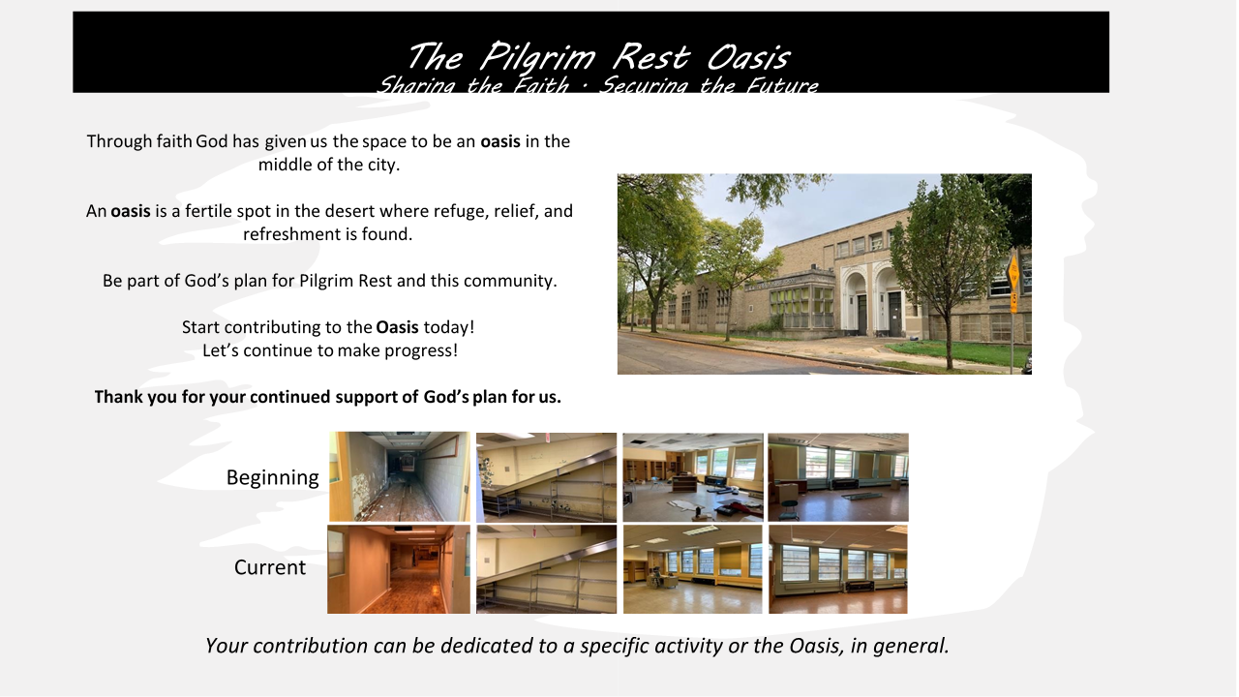

 | Educational Enrichment | Technology Literacy | Athletics & Recreation | Performing Arts | Facility Innovation
$500 | - 15 Subject books for elementary (math, literature, history, etc.) | - 1 iPad | - 10 basketballs | - 10 art sets for aspiring artists | - External security lighting to keep the street well-lit and safe
$1,000 | - 100 Summer Bridge books to help students retain learning during breaks | - 100 “learn how to code” kits for elementary students | - 10 tennis rackets | - 4 beginner saxophones or 8 beginner violins | - Camera security system to keep everyone safe
$2,500 | - 9 students can be challenged to excel using interactive problem-solving programs | - 1 computer for graphic design and website creation | - 12 sets of golf clubs for children | - 10 Play Scripts with performance/ licensing fee and cast instructions | - Wireless PA system to easily communicate at the school
$5,000 | - 1 smartboard to help teachers engage students in learning | - 1 STEM lab cart of materials for a classroom with multiple activities | - 3-day Speed and Agility workshop for 15 young aspiring track stars | - 100 pairs of tap shoes for aspiring dancers | - Battery operated floor scrubber to keep the building looking its best
$10,000 | - 1 trip for 15 students to visit 1 HBCU | - 100 Robotic kits to reinforce studies in STEAM subjects | - Open gym for 20 young people 1 X a week throughout the winter in a safe place | - 200 tickets to see Alvin Ailey Dance Company | - LED light fixtures throughout the school to promote learning and natural light

WORK FOR THE WEEK

JUNE MEMORY VERSE
² for I will speak to you in a parable. I will teach you hidden lessons from our past— ³ stories we have heard and known, stories our ancestors handed down to us. ⁴ We will not hide these truths from our children; we will tell the next generation about the glorious deeds of the Lord, about his power and his mighty wonders.
Psalm 78:2-4

JUNE MEDITATION QUOTE
“It is easier to build strong children than to repair broken men.”
Frederick Douglass

