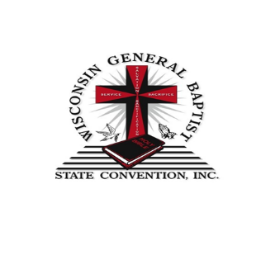
Fall Session – Virtual Classes
November 8-12, 2021
7:00 p.m. – 9:00 p.m.
​
Congress President’s Address
and Dean's Report
Thursday, November 11, 2021 @ 6:00pm

Theme: “Go and Teach” Matthew 28:19-20

November SEMINARS:
​
Understanding the Bible,
Rev. Aaron Cain
​
Developing a More Effective Prayer Life,
Rev. Martin Childs
​
Discovering & Operating in Spiritual Gifts,
Rev. John K. Patterson

The Mission & Ministry of the 21st Century Church,
Rev. Archie Ivy

Creative Ways of Teaching #2023 – (Certified),
Jean Power

Go to: wgbsc to register for class

If you do not have an email address, please select your class and call the church
Office, 414-873-1045, I will get you registered for the class and get you a phone in number, so that you can listen in.

*Need Help! Contact Dean Emma Brooks @ 414-699-5373

​

