Greetings from the WAI:

I have several things to share with you today. I'm sending it out a day early because of the Gift Card Flyer attached which takes place tomorrow (Friday morning), for those who are interested.

Milwaukee County DHHS - Community Engagement Sessions
Thursday, August 26th, 4:00-6:00pm and
Friday, August 27th, 10:00am-12:00pm
See attached flyer for more information.

The next flyer is for those who may have lost power recently from the storms that came through Milwaukee. Be sure to read, there are food gift cards available on Friday, Aug 20th 6am -10am. Locations are listed on the attached flyer.

4Th Annual NIA-AA Symposium - Oct 27th -28th this is a free & virtual event. More info below
Oct. 27-28 | Virtual Symposium | Can't see the images? Click here.

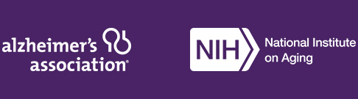
Join us for Enabling Precision Medicine — at no cost.
The Alzheimer’s Association and the National Institute on Aging (NIA) invite you to attend the 4th annual NIA-AA Symposium: Enabling Precision Medicine for Alzheimer’s Disease Through Open Science, held virtually October 27-28, 2021 at no cost. Previously offered as an AAIC preconference, this year the standalone symposium will feature an array of translational research programs that integrate computational and experimental approaches to:
- Discover novel, disease-relevant targets and biomarkers.
- Develop next-generation animal models and target enabling tools.
- Support the development of new candidate therapeutics for a diverse portfolio of targets.
- Advance data-driven drug repositioning and combination therapy development.
Register today and join academic, biotech and pharmaceutical industry researchers with an interest in target and biomarker discovery and preclinical and clinical drug development; computational biologists; data scientists; and open science advocates to drive advancements in individualized dementia treatment research.
Register today
Supported by:

Gail Morgan
Wisconsin Alzheimer's Institute Regional Milwaukee Office
UW Madison School of Medicine and Public Health
Center for Urban Population Health
1020 N. 12th St. Suite 4180 | Milwaukee, WI 53233
414.219.5124 | Phone
414.219.6563 | Fax
gdmorgan3@wisc.edu

